Revisions to Core CPI Don’t Imply Broader Inflation Pressure

FEB 13

The trajectory of the 2023 CPI will be impacted by both the new core weights and the new seasonal factors.

* *Weights*: in short, **the impact of the weights *over the course of the year* will likely be to put a bit more downward pressure on core inflation** due both to how they were redistributed among the components and to the expected path of certain components.
* *Seasonals*: the new seasonal factors simply redistribute the strength and weakness in certain parts of the year, so **they don’t affect the full-year picture**. However, they can impact the short-term trajectory of the seasonally adjusted readings. The new seasonal factors basically took what used to be strength in Q2 2022 and put it into Q4. For a given forecast path, **the new factors will act to lower Q2 2023 core inflation readings while boosting Q4 core readings**. The changes to Q1 and Q3 were small.
  + - In terms of what changed in the seasonality, the short answer is that it’s largely related to new and used vehicles, and there are slightly different stories for each that are discussed below.
    - **About two-thirds of the new drag from the seasonals in Q2 is related to autos, while about two-thirds of the boost in Q4 comes from autos**.
      * This is important in the sense that these two components were responsible for most of the upward revision to the core in Q4. Thus, I don’t think the revisions suggest broader inflationary pressures in the economy than we previously thought.

The new seasonal factors led to some swings in the data in 2022. The three-month annualized rate in June 2022 was lowered from 7.9% previously to 7.1% currently, and the December rate was boosted from 3.14% previously to 4.25% now.

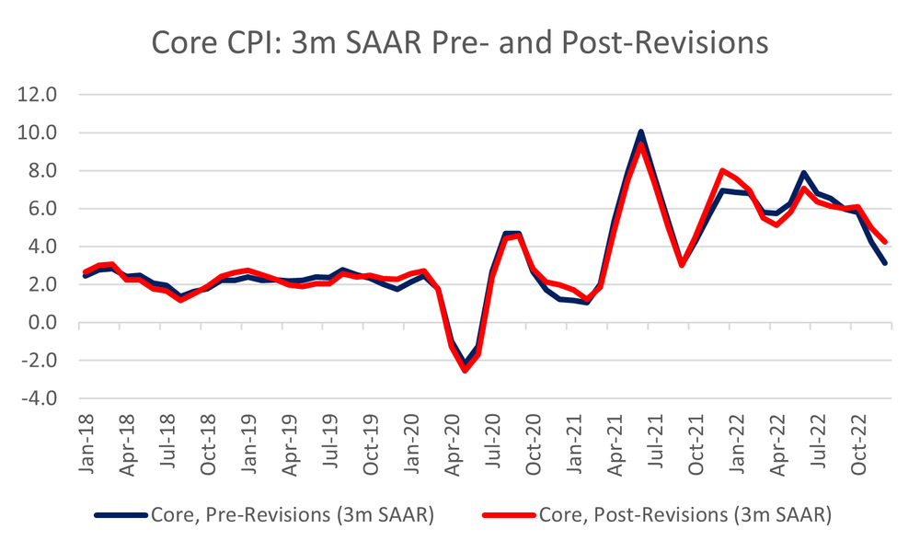

*Source: BLS, Inflation Insights Calculations*

So, while there was less inflation than we thought in Q2, there was more to finish the year. Arguably the upward revision to the year-end core rate was more important given that the prior picture of a firm disinflationary trend in Q4 looks less robust.

* That said, **it’s important to note that most of the change in the seasonal factors was centered in autos**.
  + To be clear, I’m not implying that there’s anything wrong with the new seasonal factors or that we should dismiss them.
  + Instead, **the point is simply that the revisions were only in a couple of components and not necessarily indicative of “economy-wide” inflationary pressures of the sort that just looking at the change in the 3-month annualized rate might imply**.

 In Q2, the average monthly change in the SA core was reduced by about 6.5bps due to the new seasonal factors.

* + **About 66% of the 6.5bps was due to more restrictive seasonal factors for new (2.0bps) and used vehicles (2.3bps)**.
* In Q4, the average monthly change in the SA core rate was increased by 9bps due to the new seasonal factors.
  + **Approximately, 63% of that move was due to more accommodative factors for new (2.2bps) and used vehicles (3.5bps).**

*Source: BLS, Inflation Insights Calculations*

With respect to new vehicles, the seasonal factors changed dramatically, but **this is due in large part to the change in methodology**.

* The first chart below shows the impact of the new seasonal factors on a hypothetical 1% NSA change in the new vehicles index in each month.
* As you can see, the new factors dramatically lowered the Q2 changes, especially in April, while boosting the changes in Q4, notably in November and December.

*Source: BLS, Inflation Insights Calculations*

The difference between the old and new factors is shown in the second chart.

*Source: BLS, Inflation Insights Calculations*

In any case, the new seasonals reflect the incorporation of new NSA data in the new vehicles index, which reflects the updated methodology.

* Recall that in April 2022, the CPI switched to using the “experimental” new vehicles index.
* That index showed vastly different monthly moves in prices for new autos.
* If you look at the third chart, you can see monthly NSA percent changes in the new vehicles index under the old methodology and the new methodology.
  + From April 2022, when the experimental index was introduced into the CPI, it became the official new vehicles index, which is why the prices converge (there is a slight difference in the December 2022 NSA reading, which I suspect is due to the fact that the BLS slightly tweaked the time series filter they use).

*Source: BLS, Inflation Insights Calculations*

In the fourth chart, I show the average difference in the NSA MoM% change for new vehicles under the new and old methodologies from 2018-2022.

* Not surprisingly, the new methodology showed much stronger prints in April, on average, from 2018-2021 (I excluded 2022 data from April-November since there is no wedge between the new and old methodologies there, but I included December 2022 to account for the impact of the new filter) as well as in May. Meanwhile, the new prints were weaker in November and especially in December.

*Source: BLS, Inflation Insights Calculations*

So, the incorporation of the new data for the new vehicles index explains why the seasonal factors for this series were revised so heavily this year.

* On its own, the new vehicles index was responsible for about 31% of the change in the Q2 core CPI seasonal factor, and it accounted for about 24% of the change in the Q4 seasonal factor.
* Again, I’m not pointing this out to cast doubt on the seasonal adjustment methodology. In fact, I touted the incorporation of the new methodology in April as a step forward in the way the CPI is calculated since it relied on real-time transaction data.
* Instead, **it’s worth noting that a big part of why the overall seasonal factors for the core were revised so heavily had to do specifically with just the new vehicles index**.

Meanwhile, it seems that the seasonality in used vehicles was boosted largely due to the big run-up in prices in the spring of 2021 and in June 2022.

* NSA prices for used vehicles rose by 9.6% in April 2021, 6.5% in May 2021, and 10.8% in June 2021. In June 2022, prices again increased by 2.2%.
* The strong move in June 2022 that followed the hefty June 2021 move helps to explain why the bulk of the Q2 shift in the seasonal factor occurred in June, where it is now far more stringent.
* Meanwhile, the rapid decline in wholesale prices in the summer/fall of 2022 that led to the large drops in the unadjusted data in Q4 clearly resulted in the more accommodative seasonals we see now.
  + It seems like the 2022 data played a big role in the revised seasonals given that there’s no clear pattern in the Q4 moves.
* In any case, the new seasonal will dampen Q2 moves and boost Q4 2023 used vehicles prices.

*Source: BLS, Inflation Insights Calculations*

*Source: BLS, Inflation Insights Calculations*

The revisions to the seasonal factors for both new and used vehicles were a big part of the story as to why we saw sharply higher core inflation in Q4. While we have to take the data as it is, I think the fact that much of the revised Q4 strength was centered in new and used vehicles suggests that the higher Q4 prints were less about “economy-wide”  
inflationary pressures than what just looking at the higher 3-month annualized rate might imply.